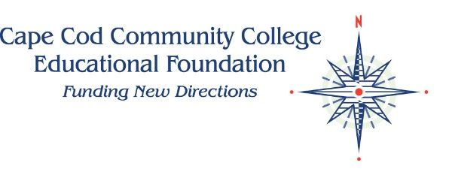

Planned Giving Commitment Form

I/We have included the CCCC Educational Foundation in my estate loans.
Name_________________________________________________________________ Date of Birth_______________
Address_____________________________________________________________________________________________
Phone:_____________________________________Email:__________________________________________________
I wish to be recognized in the CCCC Educational Foundation Legacy Society as follows:
_________________________________________________________________________________________________________
____ I wish to remain anonymous.
TYPE OF PLANNED GIFT:
__ Bequest through Will or Trust ___Life Insurance Policy Beneficiary __ Retirement plan/IRA
__ Charitable Gift Annuity __ Charitable Remainder Trust __ Charitable Lead Trust
__ Living Trust __ Other Trust __ Other____________________________________________________
Please add any other details you wish to share:________________________________________________________
All information will be kept strictly confidential.

PURPOSE OF PLANNED GIFT:
_____This gift is unrestricted to provide maximum flexibility for the Foundation.

_____This gift is restricted for the following purpose(s):
____________________________________________________________________________________________________________

Please return completed form to: Sara Anton, CEO
CCCC Educational Foundation
2240 Iyannough Road
West Barnstable, MA 02668

Completion of this form is a notification of intent only and is not intended to be legally binding. Please discuss your planned giving intentions with your professional financial and legal advisors. Cape Cod Community College Educational Foundation is a tax-exempt nonprofit organization recognized by section 501(c)3 of the Internal Revenue code. Tax ID # is 22-2475111. Contributions are tax deductible to the extents allowed by law.

